**SPH3U 11.9 Circuit Analysis**

1. **Circuit analysis when resistance values are given**

The circuit below has a source voltage of 12.0 V and resistance values of R1 = 15.0 Ω, R2 = 25.0 Ω, R3 = 35.0 Ω. Find values for Isource, I1, I2, I3, V1, V2, V3, and Rtotal.

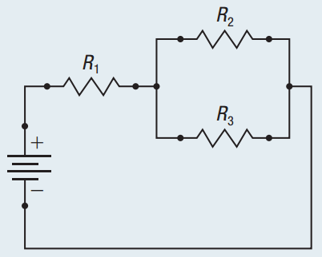

1. **Circuit analysis when only some resistance values are given**

The circuit below has a Vsource = 12.0 V, I1 = 0.50 A, V3= 2.5 V, V4 = 5.0 V, and R3 = 10.0 Ω. Find values for Isource, I2, I3, I4, V1, V2, R1, R2, R4, and Rtotal.

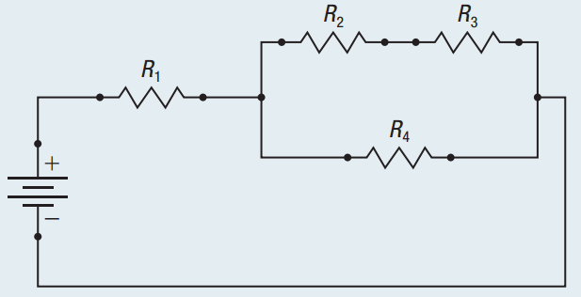

**Homework:** page 535: #1-4